Course Project: <Name>
- Members
We are: …
- Story
Please summarize your story that you have used to develop your game
- Game Design
How many characters are there in the game?
How many scenes are there in the game?
How is each character?
- Sprites
  - Sprite 1
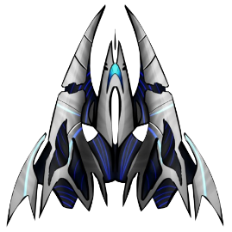
This is the sprite for main character, space warship.
…
  - Sprite 2
- Game development: Requirements
  - Requirement 1
The character 1 is moved using keyboards
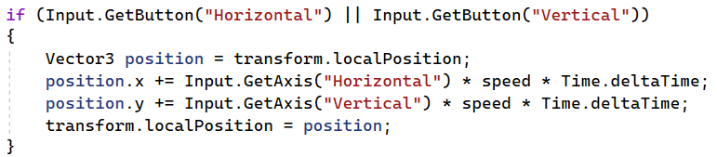
  - Requirement 2
…
- Game development: extra functions
  - Extra function 1
  - Extra function 2

- Future works
The functions that you are developing …

Appendix
1. Github: …
2. …
3. Contribution:
- Member 1: 40%
- Member 2: 30%
- Member 3: 30%...

